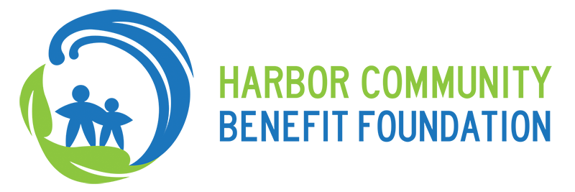

To: HCBF Board of Directors
From: Sean Hecht, Board Chair
Date: September 9, 2015
Subject: Board Consideration of Proposed HCBF/China Shipping Agreement

Background

In 2003, NRDC, Coalition for Clean Air, and two San Pedro homeowners’ associations entered into a settlement agreement to resolve a CEQA dispute involving the Port of Los Angeles’s (POLA)’s plans to expand the China Shipping terminal. The settlement agreement obligated the City and POLA to, among other things, create a $50 million air quality and aesthetic mitigation fund. Of that fund, $20 million was earmarked for reduction of air pollution from port operations (e.g., projects that reduced emissions from ships, locomotives, trucks, and tug boats).

For various reasons, the entire air quality fund was not spent by the date required in the settlement agreement; over $9 million remains today. Pursuant to the original China Shipping settlement agreement, the parties now have agreed on “an independent air quality mitigation program” to administer the funds, with “restrictions sufficient to ensure that such funds are used to reduce Port-related emissions.”

Under the proposed new agreement (“HCBF China Shipping Agreement”), HCBF will play a key role in the program to administer approximately $5.2 million of the remaining funds, by developing RFPs, soliciting proposals, evaluating those proposals, selecting projects to fund, and managing the flow of funds under the program. The terms of the draft agreement have been negotiated over the past three years among Port staff and attorneys, representatives of the China Shipping plaintiffs, and HCBF representatives. Approval of the HCBF board, the Board of Harbor Commissioners, and each of the China Shipping plaintiffs will be necessary for the HCBF China Shipping Agreement to be effective; a final version is now available for review and approval by the parties. POLA staff has requested that HCBF and the other parties execute the agreement before the Board of Harbor Commissioners vote on its approval. They are hoping to agendize it for the next BOHC meeting, on September 17.

Details of the Proposed Agreement

Of the $9.2 million remaining in the air quality fund, $4 million will be allocated to the SCAQMD, to fund SCAQMD’s trolley truck (catenary) demonstration project. The remaining $5,226,944 will be allocated to HCBF. Funds will be applied to projects that will reduce Port-related emissions.
Under the Agreement, “HCBF will administer and manage the Air Quality Mitigation Fund (‘AQMF’), including but not limited to the development and issuance of requests for proposals, evaluation, funding, and administration of grants, in a manner consistent with this Agreement.”
The AQMF will be structured similarly to the existing PCMTF managed by HCBF. The fund “shall be managed by either JPMorgan Chase Private Bank or by another appropriate independent financial manager (‘Independent Financial Manager’), selected by HCBF with BOHC’s approval, which approval shall not be unreasonably withheld.” We contemplate that we will quickly develop a proposal to engage JP Morgan (which manages our existing fund, the Port Community Mitigation Trust Fund) or another financial manager to serve as the Independent Financial Manager, and put that proposal before HCBF’s board and the BOHC subsequent to the approval of this agreement.

Similarly to the PCMTF, the BOHC must approve disbursements from the AQMF to HCBF to fund projects. The funds in the special program account are to be used

exclusively for projects that are reasonably calculated to reduce Port-related air emissions. This includes emissions resulting from the transport and handling of cargo within, into, out of, to, or from the Port of Los Angeles, including but not limited to cargo transport and handling by ships, harbor craft, trucks, locomotives, or cargo handling equipment. The projects may include the demonstration of freight movement technologies that have zero or near-zero tailpipe emissions, such as hybrid or electric vehicles and cargo handling equipment, ship emission reduction technologies, or catenary or electric truck technologies, among others. HCBF may solicit projects for funding through one or multiple requests for proposals.

Projects must be consistent with this Agreement, the Tidelands Trust Grant, and all federal, state and local laws.

More specifically, the agreement requires that

HCBF shall prioritize funding the demonstration or implementation of zero or near-zero emission freight movement technologies and other emerging technologies that seek to demonstrate significant emissions reductions from conventional diesel-fueled vehicles and equipment that operate in and around the Port (including ships, harbor craft, trucks, locomotives, or cargo handling equipment). Not less than a majority of AQMF funds shall be spent towards the demonstration or implementation of such technologies. Priority shall also be given to technologies that, if they were widely deployed, would significantly reduce air emissions and/or air quality related health risks from the largest sources of air pollution from port operations, namely ships, harbor craft, trucks, locomotives, or cargo handling equipment.

Consistent with HCBF’s mission to serve San Pedro and Wilmington, “[t]he projects funded by the AQMF are expected primarily to benefit the communities of San Pedro and Wilmington. Projects funded by HCBF shall demonstrate achievable emissions reduction benefits in communities within approximately 25 miles of the San Pedro Bay, with a primary benefit occurring in the communities of San Pedro and Wilmington, although the benefits may also extend beyond the 25-mile boundary. With respect to demonstration projects funded by HCBF under this Agreement, such projects shall be deployed or implemented within this same 25-mile geographic boundary.” Projects approved by HCBF’s board will be subject to review and approval by the Board of Harbor Commissioners, similar to the process by which projects undertaken with PCMTF funding are reviewed.

Under the agreement, HCBF will receive an initial advance payment of $250,000 for administrative costs, which we anticipate will include staff time as well as engaging technical assistance to assist HCBF with developing the RFP and vetting proposals. Subsequently, HCBF will be entitled to receive adequate funding from the AQMF to fund its administrative costs from year to year.

Recommendation to Board:

Board shall consider and vote:

To approve Harbor Community Benefit Foundation proceeding to enter into the contract presented for review, in its substantial form, known as the HCBF China Shipping Agreement;

To authorize Ben Schirmer, in his capacity as the Executive Director of the Harbor Community Benefit Foundation, to sign the final HCBF China Shipping Agreement.

